**MANF 486: Mechatronic Systems Laboratory**

Lab #6 - Electro-Pneumatic Circuits

School of Engineering

**Introduction**

Pneumatics control circuits are widely used in manufacturing facilities for a wide range of tasks and functions. Through the use of different components such as actuators, valves, and vacuum generators, compressed air can be utilized to perform various manufacturing jobs. Pneumatics are used over other technologies that can perform similar tasks for some of the following reasons:

* There is unlimited supply of air around us
* Pressurized air cannot explode or ignite
* Pressurized air is very clean, proving important in many industries
* Does not require a closed loop system like hydraulics would

Now comes the question; how do we control these pneumatic systems? Based on previous course work, it may seem that the obvious and easiest way would be to use a PLC. This is often the case, however in some circumstances a physical automation circuit can be created to control basic functionality of a pneumatic system. By doing this, a company can save the expense of a costly PLC while still maintaining a robust and serviceable system.

In this lab, we will be working on replacing the control system for a pneumatic process that we have used a PLC to control up to this point. That is, the pneumatic pick and place system that is used on the MPS pick-and-place station. This system consists of three main components; two linear actuators and one vacuum generator gripper. These components work together to pick up a lid from a slide, move across to the conveyor, and place the lid on a workpiece. This process can be controlled by creating a fairly basic PLC program but now the challenge for this lab will be to complete the same task using an electronic circuit.

Creating an electronic control circuit in the real world to control the proposed pneumatic system would prove to be tedious and inefficient. Having to troubleshoot electrical connections and setups would take up valuable time and require an abundance of different hardware components. To solve this problem, we will be using a software called FluidSIM which is a software that allows you to simulate both pneumatic and electrical systems. The software contains all of the components and we need to replicate the physical system present on the pick-and-place MPS station as well as all of the electrical components that we will need to control its functionality.

Simulation softwares such as FluidSIM are an incredibly valuable tool in the manufacturing industry. Having the ability to work out a design entirely in a simulation before implementing any hardware can save a company time and money. As future engineers, learning the basics of such software not only teaches us about the technology we are simulating but also offers a great foundation that is often looked for by employers.

**Solution Description**

To begin this lab, we modeled the MPS pick-and-place pneumatic system in the FluidSIM software. Fortunately, we have been provided with documentation from FESTO who is the manufacturer of the MPS station. The documentation contains the pneumatic diagram for the system on the station, using all the standard symbols that are utilized on the FluidSIM software. Therefore, we recreated the diagram fairly easily by exploring through the library of components in the software to match exactly what was provided in the documentation. An image of our completed pneumatic system model can be seen below:

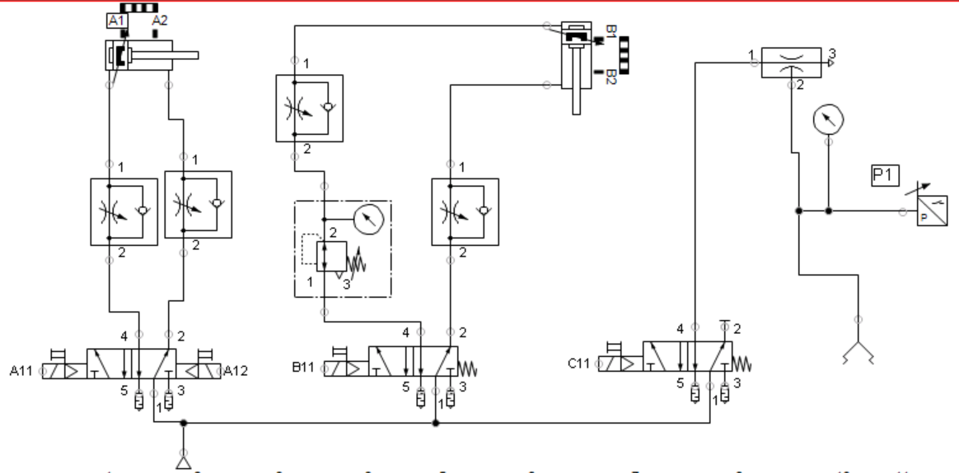

Figure 1. Pneumatic Model

*A video showing the simulation can be found at this link:* [*https://youtu.be/OHE6IMijBMk*](https://youtu.be/OHE6IMijBMk)

As noted above, we created this model based exactly on the model found in the FESTO documentation which is modeled based on the hardware found on the MPS station. It may be noted that this is not the only way to replicate the physical hardware found on the station. There are infinite ways of which one could configure different components to come up with the same basic functionality.

Finite State Machine

We identified 6 states that make up the FSM of the pick and place station (Figure 2).

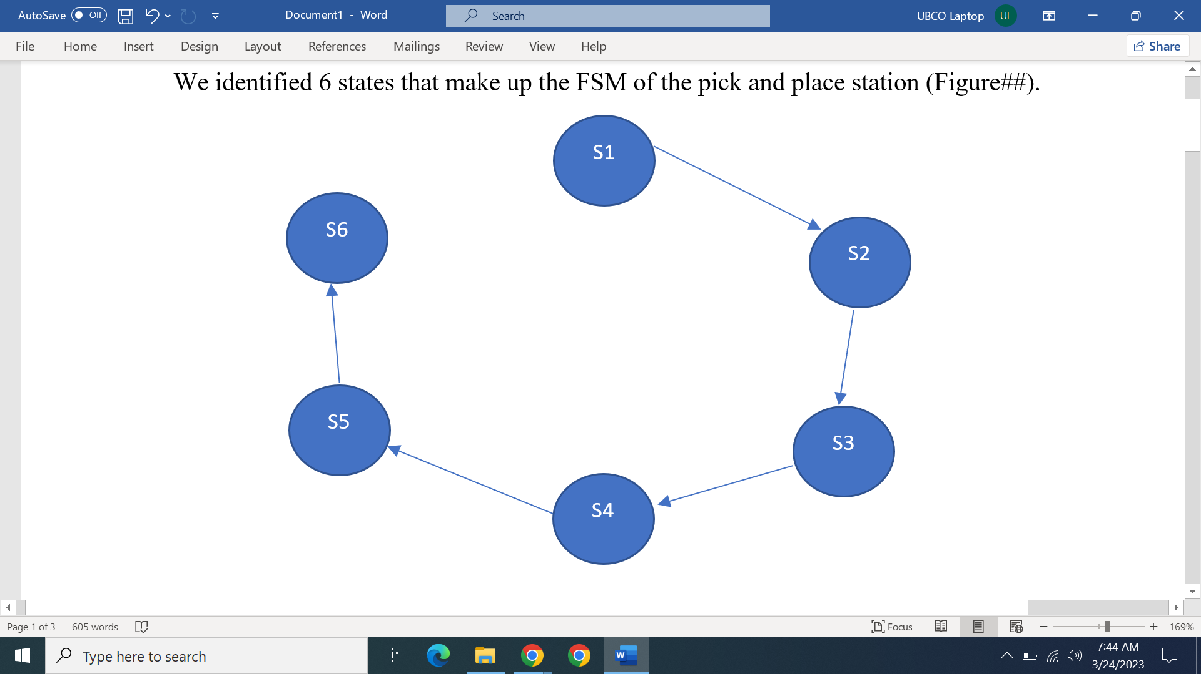

Figure 2. Finite State Machine

State 1

When in this state the station has just identified a workpiece without a lid and stopped it using the extend arm. The simulation models the movement of the arm coming down to pick up a new lid. For this purpose, the vertical pneumatic actuator extends downwards and the suction cup is turned on. To transition out of this state, the piston must be fully extended such that the proximity sensor B2 is triggered.

State 2

In this state, the suction cup is yet to make contact with the lid. In the simulation the user must manually bring down the suction cup such that it holds onto the lid. To transition out of this state, the pressure sensor must read a pressure of -12.3 psi, indicating that the suction cup has made contact with a lid.

State 3

When in this state, the arm moves upward until it is fully extended and the suction cup is still engaged to the lid. To transition into state 4, the proximity sensor B1 must detect the piston at the very top.

State 4

The arm moves outwards by action of the horizontal piston. To transition out of this state, proximity sensor A2 must read that the piston is fully extended.

State 5

The arm lowers the lid onto the workpiece through the action of the vertical piston. Once the B2 proximity sensor on the piston registers a value of true, the system transitions into the final step

State 6

Airflow to the suction cup and vertical piston is halted. This releases the lid onto the workpiece and moves the arm upward. Air is also sent to the horizontal piston so that it retracts and moves the arm inward.

Electric Control Circuit

The automation circuit used to control the pneumatic model comprises 3 circuits. The first circuit determines which state to transition the system to. The second circuit decides what actions to take when in the specified state. Finally, the third circuit contains solenoids which are commonly activated in various states.

Circuit I

For each of the states 2-6, two parallel branches are used to decide whether the state is active or not (left and right branch). The left branch has conditions which trigger the state while the right branch has conditions to determine whether the state should remain active or not.

Taking State 3 as an example, we use 4 switches on the left branch. The logic here is that state 2 should be currently active and the next step, state 4, should be inactive. The pressure sensor must be reading a value of -12.3 psi to trigger switch P1 to close. Lastly, the horizontal piston must not be fully extended. When all these conditions are met the system transitions into State 3.

Transitioning into state 3 flips the S2 switch thereby deactivating the left branch. We now consider the right branch. To remain in state 3, state 4 must currently not be active, state 3 must be active and the horizontal piston must not be fully extended.

As for state 1, the logic is that none of the states must currently be active such that S1 relay is triggered.

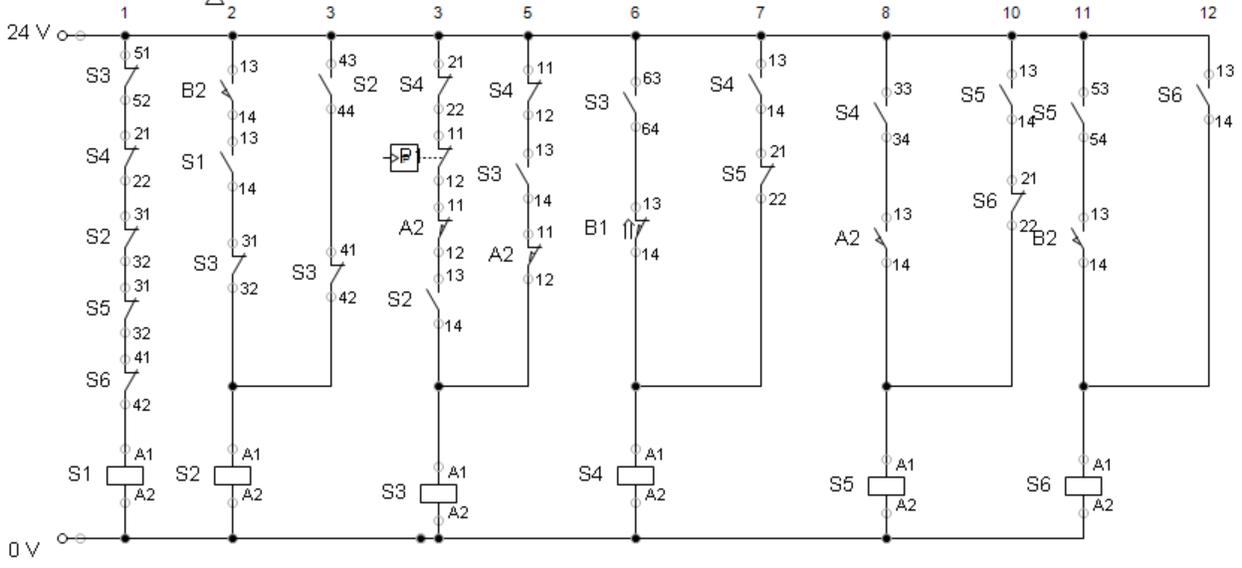

Figure 3. Circuit I

Circuit II

When a relay is triggered in circuit I, the corresponding switch in this circuit closes. This in turn activates the required switches or solenoids to activate the actuators on the pneumatic model. Using state 3 as an example once again, we see that the K2 relay is activated. These controls solenoid which move the vertical piston upward

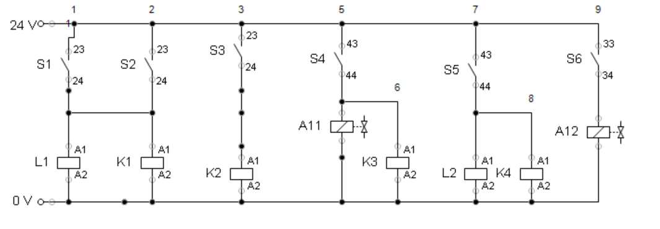

Figure 4. Circuit II

Circuit III

Certain states may require the same actuators to be activated hence this circuit is used to reduce the redundancy in circuit II. When the associated switch in circuit II is closed, the corresponding solenoid is activated which induces actuation in the pneumatic model.

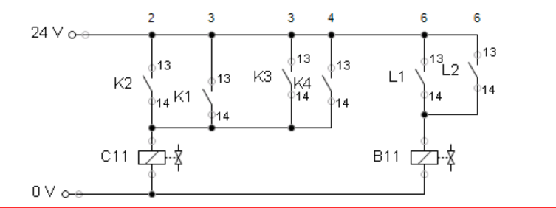

Figure 5. Circuit III

**Solution Assessment**

Sequence and Timing

Timer relays were not used in the control circuit but rather the sequence of steps carried out by the pick and place operation solely depended on sensing data. This is good as it ensures that the actuators are in the correct position before transitioning into a different step. However, the pick and place station used in the lab does not have the proximity sensors necessary to judge the position of the piston as it extends and retracts. This is one shortfall of our model. However, in cases where these proximity sensors are available, this solution would be applicable.

Process Interruption

The pick and place operation may need to be interrupted at times. The current solution does not account for this as the process continues until the lid has been placed on the workpiece. Ideally, this functionality should be incorporated through the use of a stop button. A possible addition to the control circuit could be to add another state which is activated by pressing a stop button, thus returning the pneumatic model to a default configuration where debugging could be carried out.

**Conclusion**

In this lab, we successfully designed and simulated an electronic control circuit to replace the PLC control system for a pneumatic pick-and-place system using the FluidSIM software. This allowed us to create a cost-effective alternative for controlling the pneumatic system without compromising its functionality. We demonstrated how the simulation software can be an invaluable tool for design, troubleshooting, and optimization of pneumatic systems prior to physical implementation, saving both time and resources.

We modeled the MPS pick-and-place station, created a finite state machine to represent its operation, and designed an electronic control circuit to manage the system's states and transitions. Despite certain limitations, such as the absence of timer relays and provisions for process interruption, our solution proved to be effective in controlling the pneumatic system.

For future improvements, we suggest incorporating timer relays to refine the system's sequence and timing control. Additionally, integrating provisions for process interruption, such as a stop button, would enhance the flexibility and safety of the system. Exploring alternative actuator configurations and optimizing the control circuit for energy efficiency could also lead to further improvements in the overall design.

The knowledge and skills gained during this lab have broader applications in the engineering and manufacturing industries. The ability to design, simulate, and optimize pneumatic systems using simulation software can be applied to a wide range of applications, including automation, robotics, and material handling. Furthermore, the experience of working with finite state machines and electronic control circuits can be invaluable in designing and implementing control systems for various types of machinery and processes.

In conclusion, this lab has provided a solid foundation in understanding pneumatic systems and their control mechanisms. It has also illustrated the importance of simulation software in the engineering and manufacturing industries, equipping us with valuable skills that can be applied in various professional settings. By suggesting next steps for design improvement and recognizing the broader applications of the knowledge and skills gained, we have demonstrated the potential impact of our learning on real-world challenges and opportunities.